Student Activity
13 Analysing motion with a motion sensor

TASK
To investigate the relationships between the motion of an object—you—and a graph of position and time for the moving object.

THEORY
When describing the motion of an object, it is essential to know where it is relative to a reference point, how fast and in what direction it is moving, and how it is accelerating (changing its rate of motion). A sonar ranging device such as an ultrasonic motion sensor uses pulses of ultrasound that reflect from an object to determine the position of the object. As the object moves, the change in its position is measured many times each second. The change in position from moment to moment is expressed as a velocity (m s^{–1}). The change in velocity from moment to moment is expressed as an acceleration (m s^{–2}). The position of an object at a particular time can be plotted on a graph. You can also graph the velocity and acceleration of the object versus time. A graph is a mathematical picture of the motion of an object. For this reason, it is important to understand how to interpret a graph of position, velocity, or acceleration versus time. In this activity you will plot a graph of position in real time; that is, as the motion is happening.

EQUIPMENT
• electronic measure interface and software
• base and support rod
• motion sensor

NOTES ON METHOD
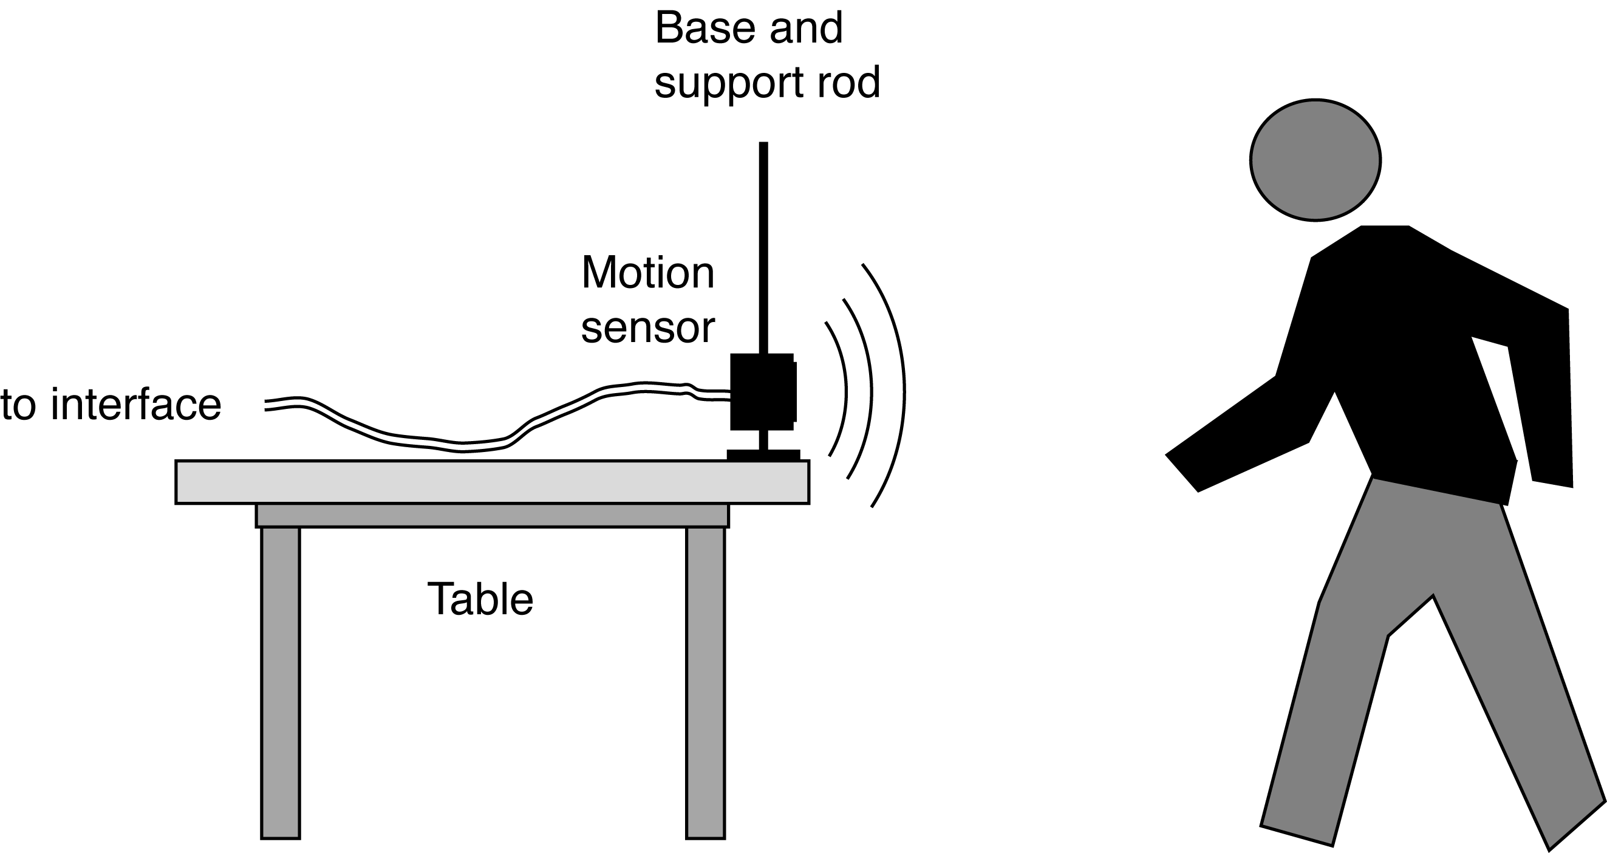

For this activity, you will be the object in motion.
The motion sensor will measure your position as you move in a straight line at different speeds.
The software that supports your sensor will plot your motion on a graph of position and time.

ICT
Setting up the motion sensor
Graph: position–time.
Sample rate: 10 samples per second (10 Hz).
Stop condition: at 10 seconds, if available.
You do not need to calibrate ultrasonic motion sensors for temperatures around 20°C.
Consult the manuals for your electronic measuring equipment or see your teacher for the options to set these values with your equipment and software.

Measuring
1. Mount the motion sensor on a support rod so that it is aimed at your waist when you are standing in front of the sensor. Make sure that you can move at least 2 metres back from the motion sensor.

2. Position the computer monitor so you can see the screen while you move away from the motion sensor.
Make sure the graph of position–time is visible and active.
3. When you are ready, stand in front of the motion sensor and click the RECORD button to begin recording data.
Data recording will begin almost immediately.
The motion sensor will make a faint clicking noise. Your partner should not be able to see you while you are moving.

13 Analysing motion with a motion sensor
continued
4. Watch the plot of your motion on the graph, and try to move back and forward so that the plot of your motion creates a relatively simple position versus time plot.
Data recording will end automatically after 10 seconds (stop condition), or you can click the STOP button to end sooner.
Run #1 will appear in your Data list in the Experiment Setup window.

5. Now invite your partner to try to precisely match your graph.
Your partner’s trace can be set to appear directly over your own.

6. Try a more complex motion, or ask your partner to leave the room while you create the initial graph.
Invite them back to try to match the graph of your movement without having seen your movement first-hand.

7. Repeat steps 3 to 6, but this time swap roles with your partner so that you try to match their movements.

DATA & ANALYSIS
Use your software to draw a velocity versus time graph of the position versus time data.

CONCLUSION
Comment on your own ability to match other people’s position–time graphs.
What were the main clues to how they had originally moved?

QUESTIONS
1. What is the description of your motion? (Example: ‘Constant speed for 2 seconds followed by no motion for
3 seconds, etc.’)
2. Describe one of your ‘match’ graphs in words.

